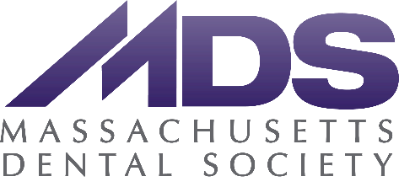
Two Willow Street
Southborough, MA 01745-1027
800.342.8747 • Fax: 508.480.0002
massdental.org

Testimony for the Executive offices of Health and Human Services
By Massachusetts Dental Society
President Dr. Meredith Bailey
November 5, 2021
101 CMR 314.00: Dental Services (to be renamed as “Rates for Dental Services”)
The Massachusetts Dental Society appreciates that the proposed MassHealth dental reimbursement rate increase reflects the increased costs and challenges dentists have faced as a result of the ongoing COVID19 pandemic. Oral health remains essential to overall health, even as the COVID 19 pandemic necessitated more costly standards of care to protect everyone.
Historically, MassHealth reimbursement rates have been unsustainable for the majority of dental offices in the Commonwealth, and, for many providers, they do not come close to covering the cost of providing care. Healthcare is local and patients deserve to see a provider in their community who they trust. Those patients are then more likely to seek out continuity of care leading to fewer dental emergency visits and improved overall health.

Fee increases are a step towards greater access to care for Medicaid recipients, and these reimbursement rates must be fair to all providers to ensure a broad reach across the Commonwealth.
Administrative and logistical burdens of the system also create barriers for providers such as challenging and unreliable reimbursement methods and a cumbersome credentialing process. For providers, these issues make the prospect of participating in this vital program untenable for many local practice owners who do not receive supplementary federal funding.
Many dentists participate in the MassHealth program in an effort to serve their communities and our state’s most vulnerable populations. However, unlike medical and related care, MassHealth coverage only provides partial dental coverage for adults. The MDS and its members have long supported full dental coverage for adult MassHealth members as part of a broader approach to increase access to effective oral health care for underserved populations and to prevent untreated dental disease that can result in health issues such as systemic infection and negative impacts on other medical conditions such as diabetes and heart disease.
The MDS and MassHealth share the goal of improving oral health in the Commonwealth, and the MDS is committed to continuing to work with civic leaders on policies to protect patients, preserve the quality of patient care, and eliminate financial uncertainties. We appreciate the proposed MassHealth dental reimbursement increase and look forward to continued effort on improving the MassHealth program to better serve the people of Massachusetts.
--
Meredith A. Bailey, DMD
President, Massachusetts Dental Society

